Pics of wire dress:

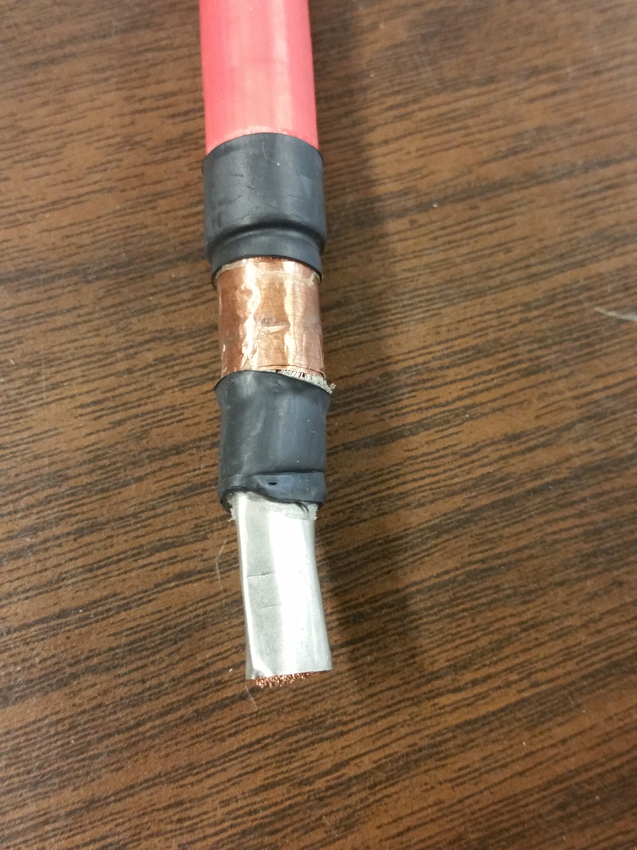

We have HV rated adhesive heat shrink to keep isolation between shield and core.

To keep the shield more managed, we use copper tape. The back of the copper tape is conductive to make the shield conductive to ground.

This shows dress of a wire when shielding is not exposed for grounding. We use HV rated adhesive heat shrink to provide barrier between core (and stud) and shielding.

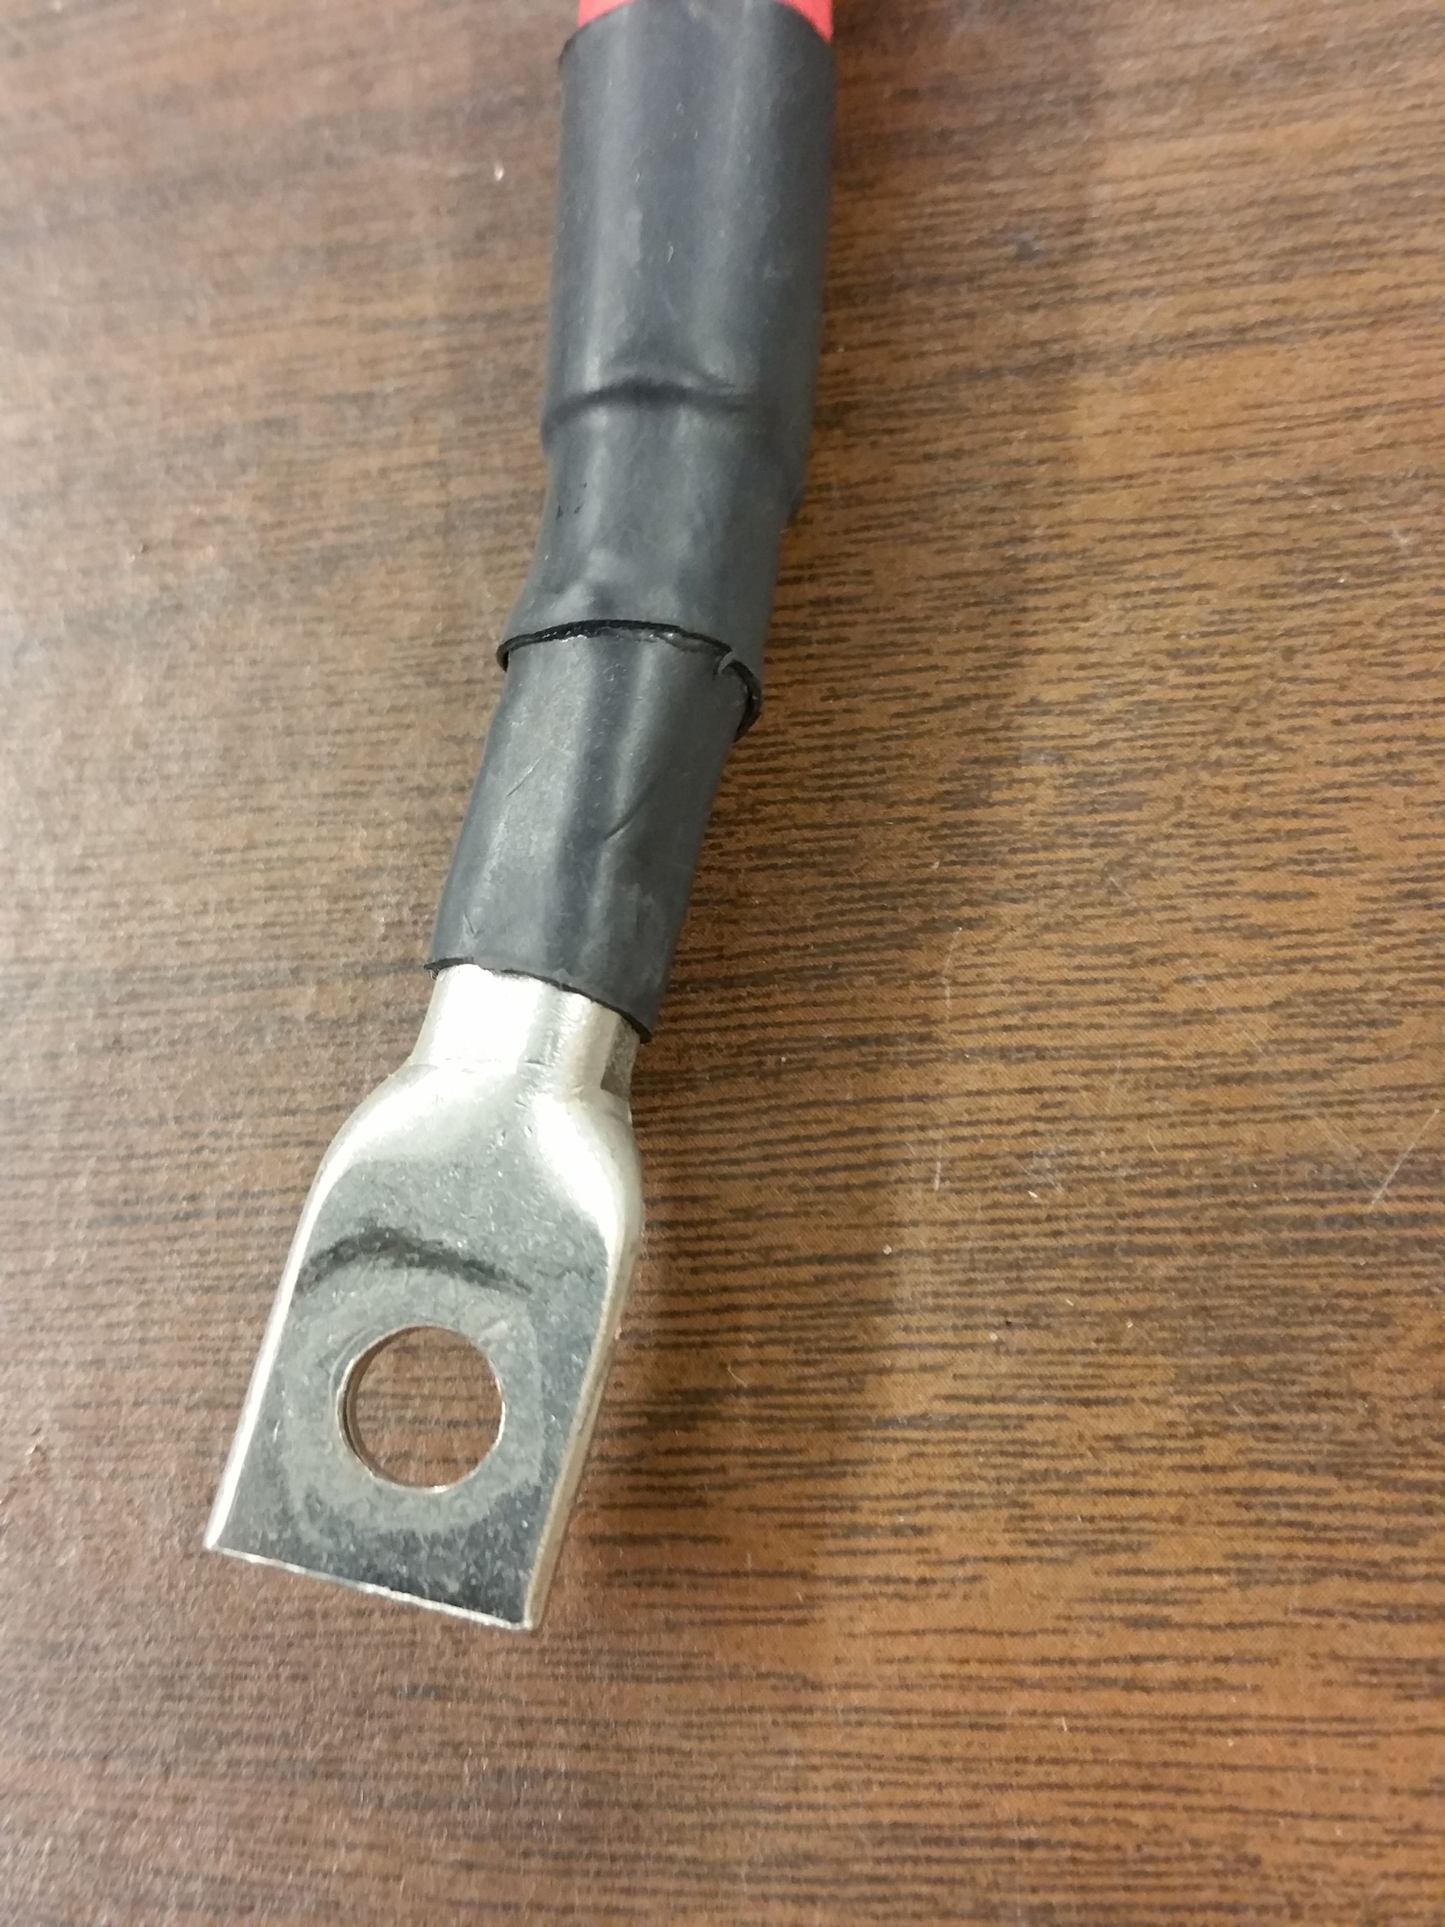

Battery cart and charging. Shows estop mounted.

